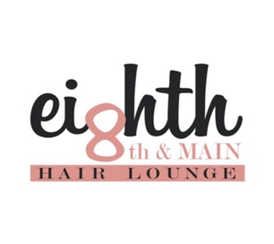Consultation form: email to eighthandmainhair@gmail
WHERE DID YOU HEAR ABOUT US?
HAIRCUT:
What challenges are you having with your haircut? What do you like most about your current haircut?
Do you have any scalp challenges that we need to know about?
HAIRCOLOR:
When was the last time you had your hair professionally colored? # of weeks: 3 4 5 6 7 8 9 10 Other+
What did you like most about your hair color?
If there were anything you could change or improve about your hair color what would it be?
Circle Answer: Would you like your hair color to be: A) Subtle B) Dramatic or C) Somewhere in between?
On a scale of 1 – 10 (10 being the most dramatic where is it now?) Highlight One: 1 2 3 4 5 6 7 8 9 10 What would you like it to be and by when?
CONDITION:
On a scale of 1 – 10 (10 being the best) what would you rate the overall condition of your hair? Highlight One: 1 2 3 4 5 6 7 8 9 10 What would you like it to be and by when?
Let’s discuss the products you’re currently using for your daily routine.
PRODUCTS: Let’s start with your...
Shampoo:
Conditioner:
Styling Products:
Finishing Products:
Tools to Style:
What is the ONE thing you would MOST want to change or improve today?

